Name:- Saniya Mallick

Enroll no.:- ADT23SOCB1554

Class:- DA-1 SY IT

Subject:- Web Programming

Title:- Assignment 1B

**1. Determine your site structure or Create content for your core website pages:  
a. Home page**

The home page is where the user’s journey begins. It should give them an instant feel for what the platform offers recommendations of music and artwork based on their current mood or the time of day.

1.

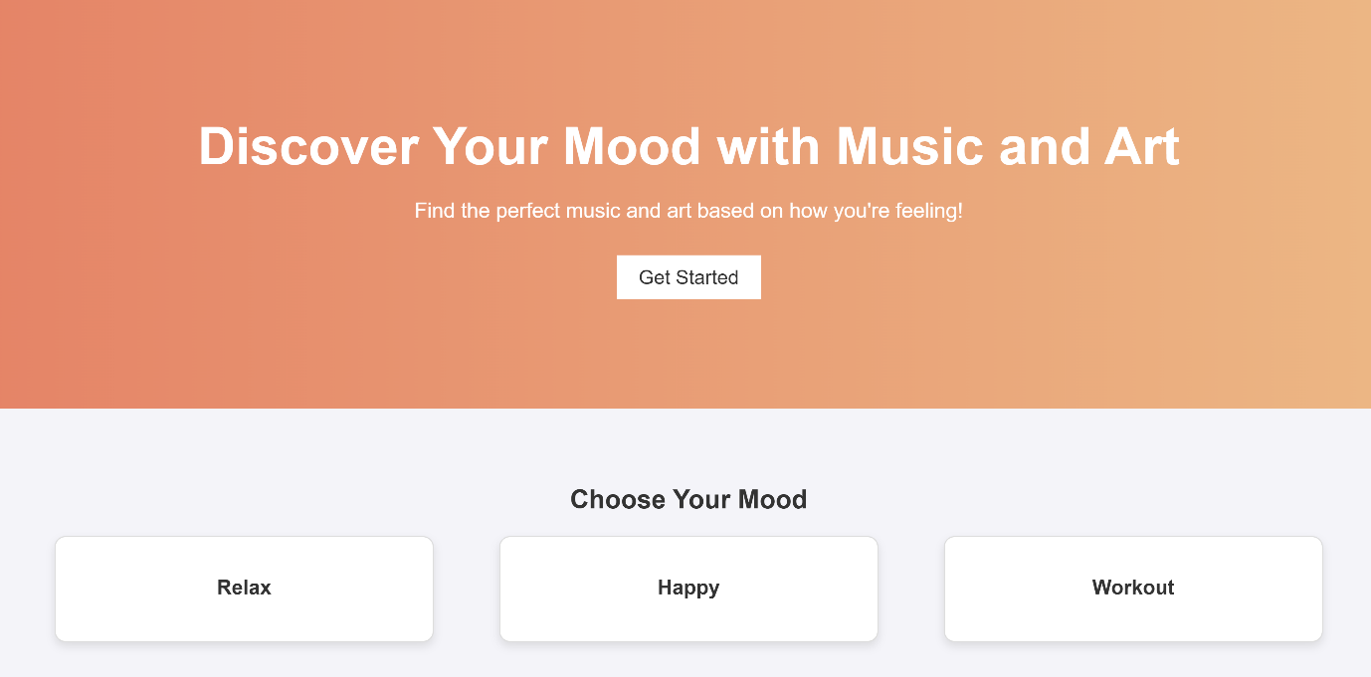

2.

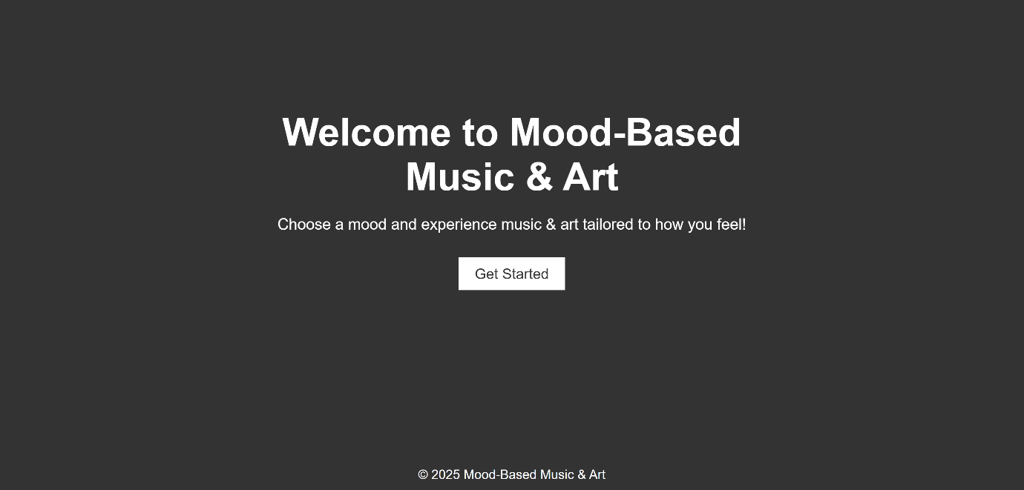

Exisiting example:-

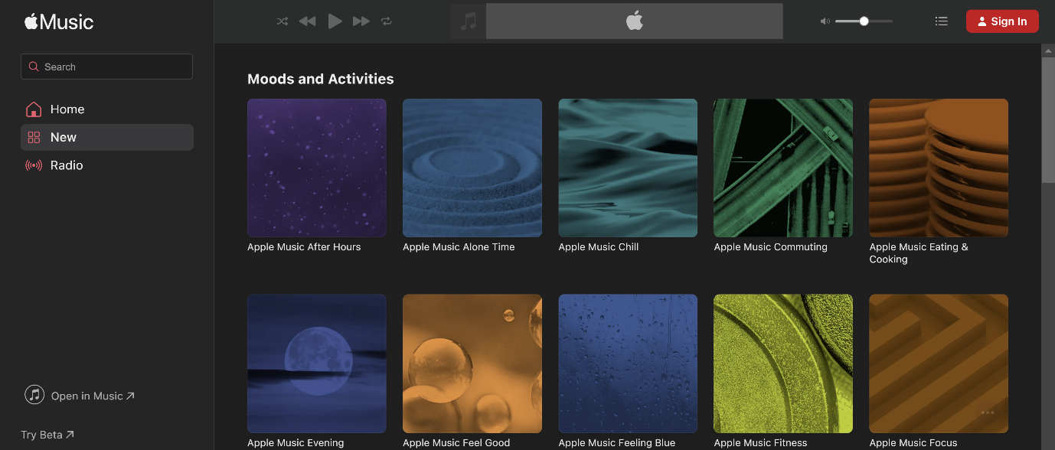3.

**b. About Page**

**Goal:**  
Introduce the platform, its goals, and its vision.

**Content & Features:**

**About Section:**

* Introduce the purpose of the platform: mood-based music and art recommendations for users looking for personalized experiences.

**How It Works:**

* Briefly explain the process of mood selection, music/art pairing, and the platform’s algorithm.

**Vision and Team:**

* Share your mission statement and introduce the developers or team behind the platform.

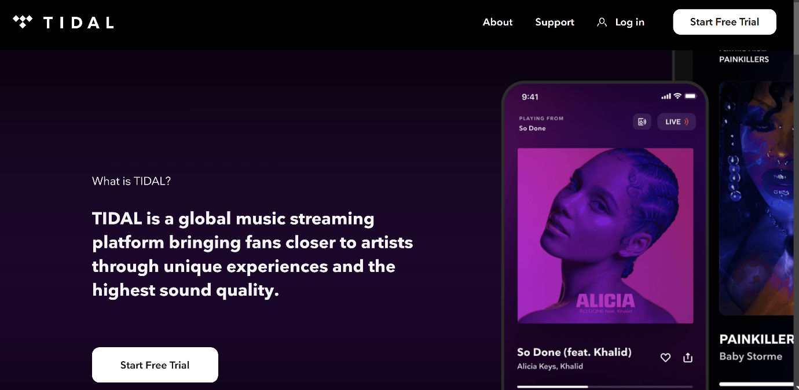

**c. Product/Service Page**

**Goal:**  
Highlight the key services offered by the platform, such as mood-based music and art recommendations.

**Content & Features:**

* **Mood-Based Music Recommendations:**  
  Users can select moods like “Happy,” “Chill,” “Motivational,” etc., and get curated playlists.

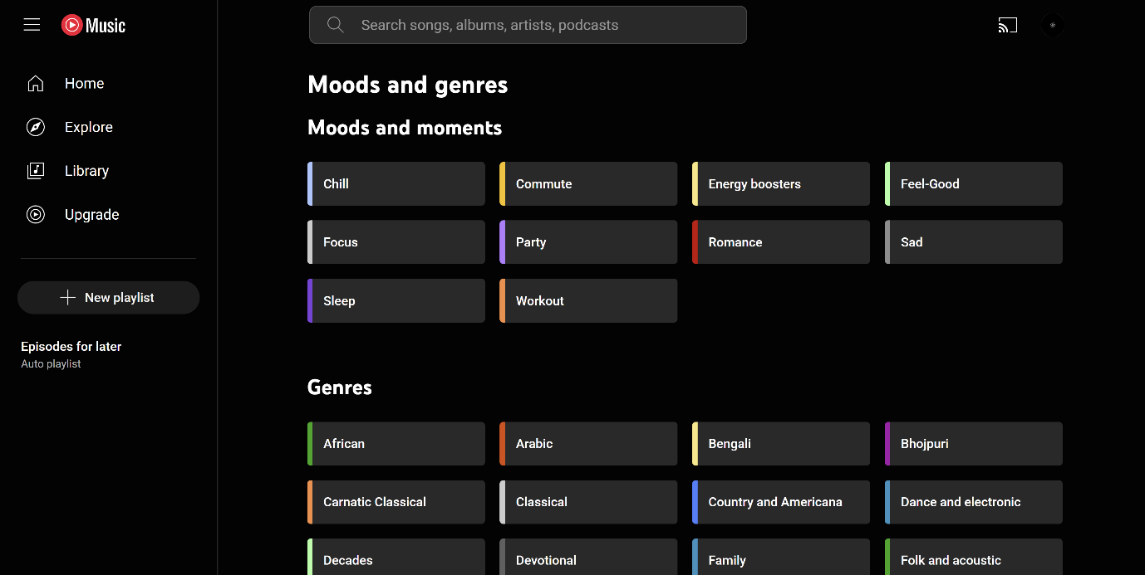

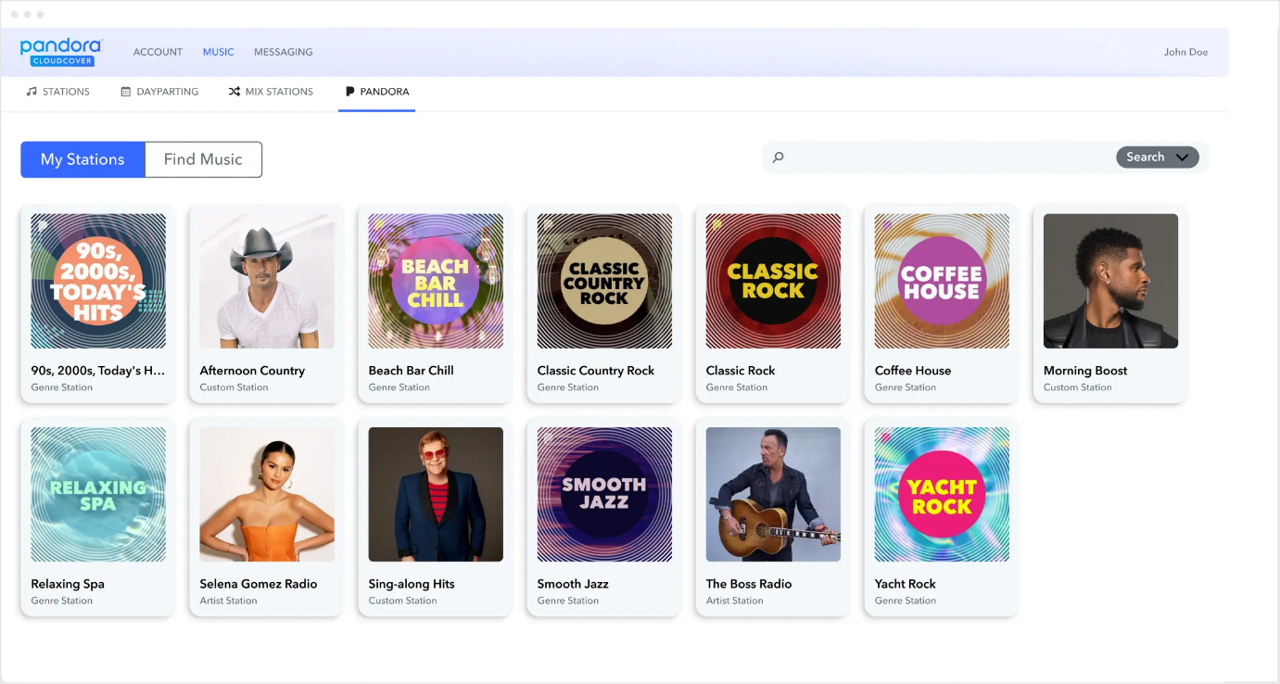

* **Art Recommendations:**  
  Fetch mood-based artwork from APIs like Pixabay or Unsplash to pair with music recommendations.

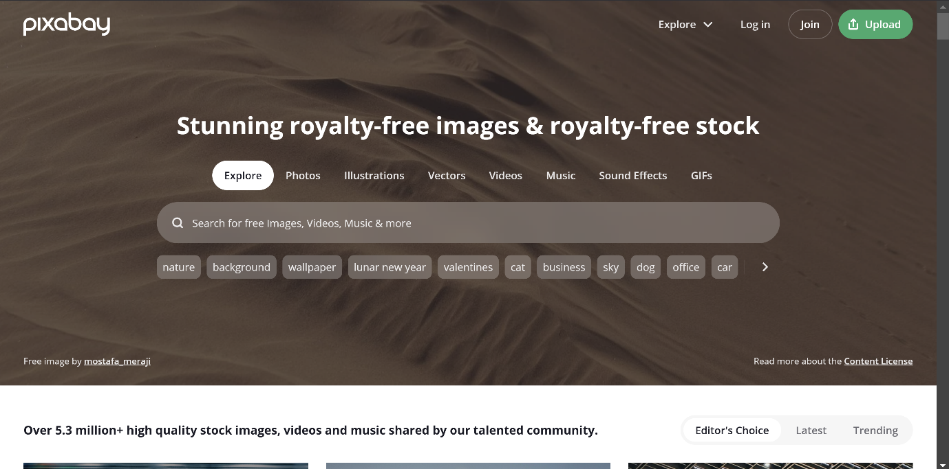

**d. Testimonial/Review Page**

**Goal:**  
Showcase feedback from users to increase trust and encourage others to use the platform.

**Content & Features:**

* **User Reviews:**  
  Share feedback from early users or beta testers to highlight how the platform has benefited them.
* **Ratings:**  
  Allow users to rate their music/art experience, similar to how [Google Play](https://play.google.com) shows ratings for apps.

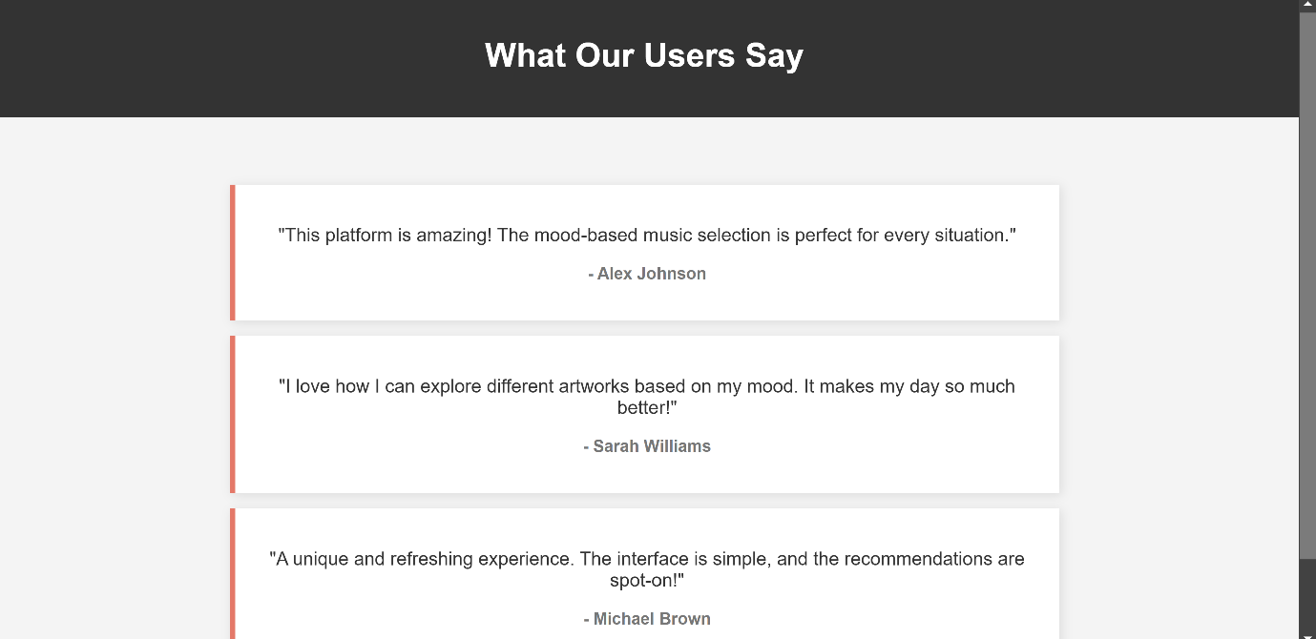

**e. Contact Page**

**Goal:**  
Let users reach out for support or inquiries.

**Content & Features:**

* **Contact Form:**  
  Include a simple contact form for users to submit their questions or issues.

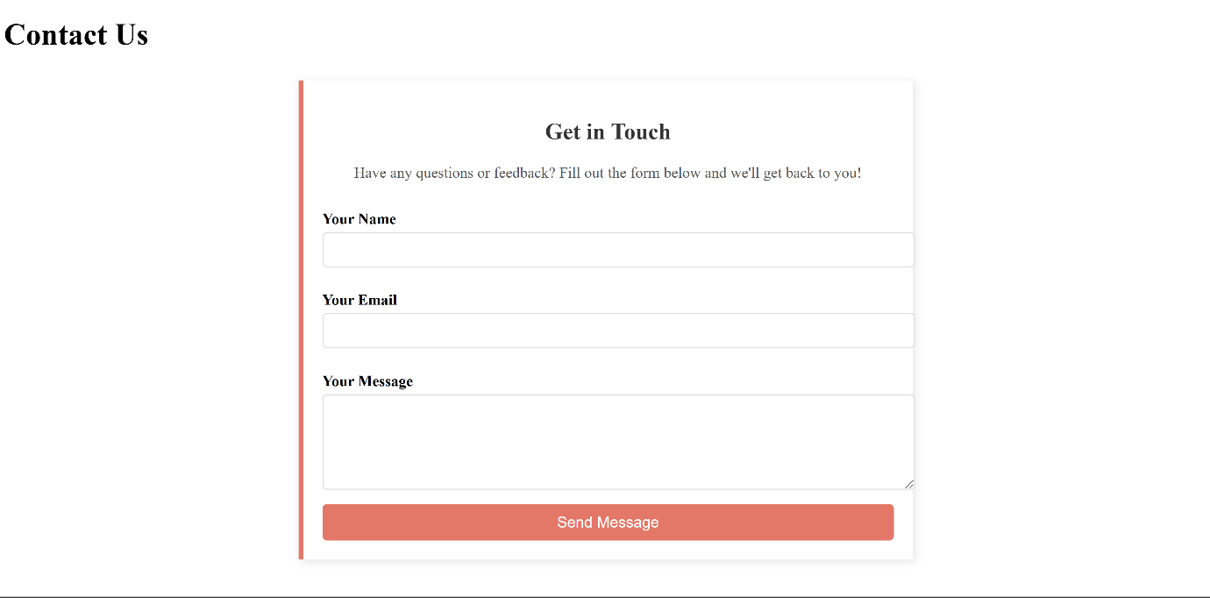

**f. Starter Blog Posts**

**Goal:**  
Engage users with blog posts related to music, art, and mood-based experiences.

**Content & Features:**

* **Blog Introduction:**  
  Welcome users to explore the blog and learn more about mood-based music/art.

**Content Ideas:**

* **"How Music Affects Our Mood"**

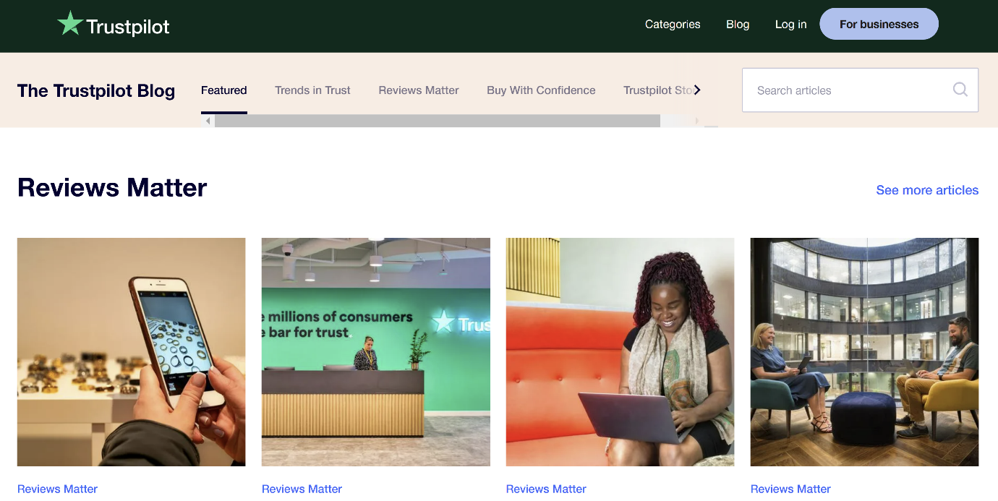

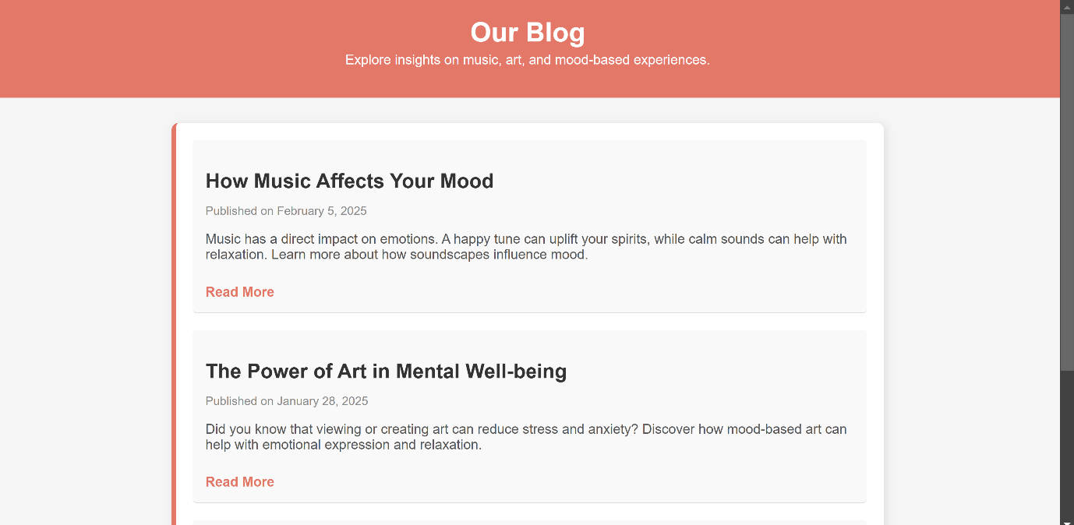

**2. Create and collect design elements**These design elements define your brand personality and help customers feel what your brand represents through the use of:  
**a. Colors:-**

* **Option 1: Orange & Black**
  + **Primary:** White (clean background), Black (text, icons)
  + **Accent:** Vibrant Orange (buttons, highlights)
* **Option 2: Purple & Yellow**
  + **Primary:** White (background), Charcoal Black (text)
  + **Accent:** Purple (art/music vibes), Yellow (highlights, calls-to-action)

**b.Fonts and Typography:**

* **Primary:** Poppins (bold, modern)
* **Secondary:** Roboto (readable body text)

**c.Logo:**

* Simple, creative music/art-related icon with a two-tone color scheme

**UI/UX Design:**

* Minimalistic, clean layout with plenty of whitespace.
* **Card-based design** for displaying music, artwork, and recommendations.

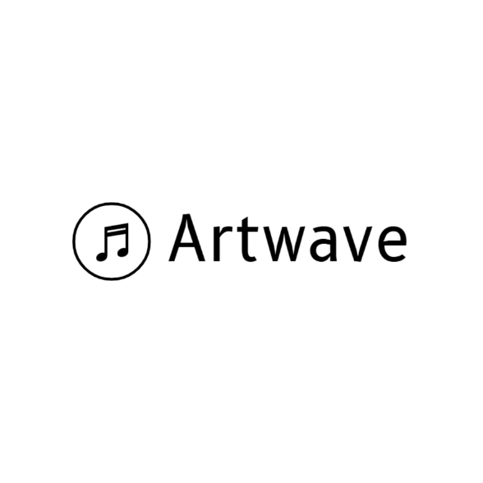

**d.Images & Art:**

* Use vibrant visuals from **Pixabay/Unsplash** to match the mood (e.g., energetic visuals for workout/party themes).

